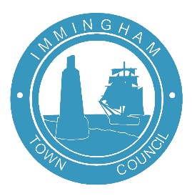**IoIMMINGHAM TOWN COUNCIL**

Civic Centre, Pelham Road, Immingham, DN40 1QF

**Tel (01469) 727272 email enquiries@immingham-tc.gov.uk**

**Annual Town Meeting**

The One Hundred and Thirtieth Annual Town Meeting will be held on Tuesday, 21 May 2024, in the Burton Hall, Civic Centre, Pelham Road, Immingham, at 18:15pm

Should you wish, you can also email andyhopkins@immingham-tc.gov.uk with items

you wish to raise, and these will be presented to the meeting on your behalf.

**A G E N D A**

**Such persons only as are registered as local government electors for the Town will be entitled to vote at the meeting**

1. Apologies

2. Minutes of the One Hundred and Twenty Ninth Annual Town Meeting held on 23 May 2023, to be signed as a true record

3. To receive the Annual Report of the Lady Mayor and Chair of Immingham Town Council

4. Public Questions

**Cllr Karen Swinburn**

**Lady Mayor & Chair of Immingham Town Council**

**10 May 2024**